SPONSORSHIP FORM
Outstanding Senior Awards - 2025
I would like to sponsor the Outstanding Senior Awards Afternoon Tea by placing an ad and/or a personal message in the Commemorative Booklet.
Contact name (please print): _________________________________________________________________________
Tel. No: ______________________________

Name and/or company / organization: ________________________________________________________________
Email: ____________________________________________________________________________________________
Address: __________________________________________________________________________________________________
I wish to place an ad or personal message in the Outstanding Seniors Awards Commemorative Booklet. Please see the Sponsorship Packages document for a complete description of privileges per level of sponsorship.
Platinum - inside back cover or outside back cover (full page – 8.5 in tall x 5.5 in wide) ____ $700
Gold - (full page– 8.5 in tall x 5.5 in wide) ____ $500
Silver - (half page - 4” tall x 5” wide) ____ $300
Bronze - (business card size) ____ $200
Personalized congratulatory message from family/friends to a winner (write message below) ____ $50
In kind donation of door prize (indicate Item & Value) ______________________________________ $ ____

All ads or messages will be printed in colour. Please send a digital copy (png or jpeg) and the completed form by e-mail to kate@gerontologis.com
Deadline for sponsored ads is September 12, 2025
To business sponsors: Would you like to attend the Sunday, Oct 5th (2-4pm) Afternoon Tea Celebration at the Baie-de-Valois Nautical Centre, Pointe-Claire? Yes ___ No ___ (1 ticket per company due to space restrictions)
NOTE: Family and friends of winners will receive a separate invitation to register their presence.
SHORT PERSONALIZED CONGRATULATORY MESSAGE (printed in the booklet):
Family/friends of winner, please write out your personal message here. Please check off $50 above. We will do the text graphics: ____________________________________________________________________________________________________________________________________________________________________________________________________________________________________________________________________________________________________________
Please make your cheques to KATE COULTER SENIOR SERVICES INC.
(mail to: GerontoLogis -132 Evergreen Dr, Beaconsfield, Qc H9W 2A2)
OR etransfer to kate@gerontologis.com For additional information please contact Kate Coulter at 514-825-4501
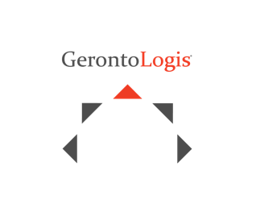


Thank you, on behalf of your hosts: GerontoLogis, Golden Home Care and the beneficiary - Lakeshore General Hospital Foundation.

